Wetland Role for Climate Change Mitigation and Defence
July 7-8, 2026, Riga, Latvia
Agenda

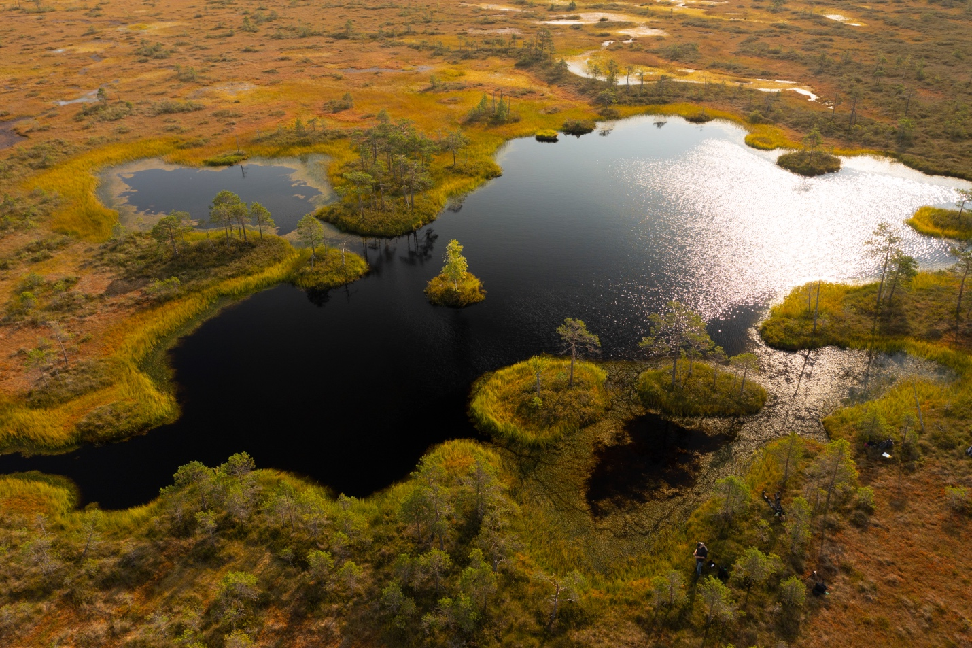

DAY 1  Time* | Agenda item | Speakers
08.30-  09.00 | Registration of participants, welcome coffee | Venue: House of Nature, University of Latvia, Jelgavas Street 3, Rīga, Auditorium 301. 3rd floor
9:00-  9:30 | Opening and welcome  - Welcoming remarks and presentation of the programme  - Welcoming remarks, NATO Climate Change and Security Centre of Excellence  - Welcoming remarks, Ministry of Defence  - Welcoming remarks, University of Latvia | Moderator: Jānis Liniņš (LV)  Director Mathieu Bussieres  State Secretary Airis Rikveilis  Vice Rector Enno Ence
09:30-  10:50 | Policy and planning  The session sets the stage by highlighting wetland policy and planning activities | Moderator: Valdis Kuzmins (LV)  - Līga Platace. (LV). Wetlands in Latvia’s greenhouse gas inventory. Ministry of Climate and Energetics.  - Jānis Zitāns (LV) Peatland rewetting projects in Latvia, planning and perspectives. JSC “Latvijas valsts meži”.  - Kristīne Sirmā, Einārs Mednis (LV). Peatland Rewetting: Current Options, Voluntary Certification and the CRCF Methodology. Ministry of Agriculture  - Maksis Rūdolfs Apinis (LV). Climate and nature conservation obligations and funding, possible synergies with other sectors (ZIZIMM GHG emission decrease and peatland rewetting. Green liberty  - Mona Koehler-Schindler (NATO). Operationalization of NATO’s Climate Change and Security Agenda within the NATO Military Authorities. NATO
10:50-11.20 | Coffee break
11.20-12.45 | Panel discussion  Peatland rewetting for climate change mitigation  This session explores peatland rewetting experiences in Latvia, Lithuania | Moderator: Roberts Gorodko (LV)  University of Latvia  Speakers:  - Daina Galaktionova (LV). Peatland rewetting consequences in Rampa peatland in Ādaži military training area, Ministry of Defence  - Philipp Gramlich (NL). Rewetting peatlands as an earning model for landowners. Stichting Turfvrij (ANBI)  - Nerijus Zableckis (LT). Peatland restoration for security and nature in Lithuania. Foundation for Peatland Restoration and Conservation  - Dr. biol. Māra Pakalne (LV). Peatland rewetting experience in Latvia, borderland peatlands. University of Latvia
12.45-13:45 | Lunch
13:45-  15:05 | Peatlands for Security and Defence, Lessons Learned  The session highlights showcase, where each case shows different rewetting | Moderator: Ilze Angere, CCASCOE  Speakers:  - Dr. hist. Kārlis Dambītis (LV). The role of wetlands in warfare, the case of Latvia. National Defence Academy  - Lcol.Gatis Vīksniņš, (LV). The impact of wetlands on mobility and counter mobility in defensive operations. National Armed Forces of Latvia  - Dr. Ieva Līcīte (LV). Rethinking peatland rewetting: climate, restoration and security in one intervention. LSFRI “Silava”  - Anke Fischer (GE). Resilience by Design: Rewetting Peatlands for Climate and Security”. NABU
15:05-  15:30 | Coffee break
15:30-  16:50 | Hydrological Modification Impacts to Human Security | Moderator: Andrew Sirjoosingh, CCASCOE  Speakers:  - Dr. Alexander S. Kolker (USA). Restoration of the Mississippi River Delta and the Overlap between Hydrology, Biological Productivity and Climate Security  - Dr. Reiner Zimmermann (DE). Wetlands for Defense: An advantage or also a burden? Lessons from history and implications for future conflicts, ENSEC COE  - Dr. Sarah Mercier-Tigrine (FR). Evolution of the rasputitsa phenomenon and wet soils in Europe with climate change, French Ministry of Armed Forces  - Jan Kunnas (FI). Restoring the (Finnish) Eastern Border as a Way to Combine the EU Nature Restoration Regulation and National Defense Needs, University of Eastern Finland
16.50-17:00 | Conclusions

DAY 1  Time* | Agenda item | Speakers
19:00-  20:30 | Informal dinner and networking at the Botanical Garden, University of Latvia,  Šteinhauera street 2, Riga, Latvia

DAY 2  Time | Agenda item |  | Speakers
09:00-  09.45 |  | Venue: House of Nature, University of Latvia, Jelgavas Street 3, Rīga, Auditorium 301. 3rd floor  Dr.hist. Kārlis Dambītis. Presentation about Stompaku Mires
10:00-10:45 |  | Pick up for site visit  Meeting location: House of Nature, University of Latvia, Jelgavas Street 1, Rīga Transfer to site visit
10:45 – 12:00 |  | Site visit to Cenas Mire, Guide: Dr. Māra Pakalne  Cenas Mire is an especially protected nature area. It is a raised bog where restoration activities were carried out in 2007.  The walk will lead along a nature trail along Skaists lake. Length of the trail 4 km.  More information about the site:  https://www.peatcarbon.lu.lv/fileadmin/user_upload/lu_portal/peatcarbon.lu.lv/Publikacijas/buklets_CENAS_TIRELIS_2025.pdf
12.00-  14.00 |  | Lunch, transfer to Tīreļu Mire
14.00-15.30 |  | Site visit to Tīreļu Mire, Guide: Kārlis Dambītis  The Christmas Battles Museum, a branch of the Latvian War Museum, is located at the historic First World War battle site near the Maztirelis Mire. This area of the First World War is unique for its preserved and restored fortifications situated within the marshland terrain. At the authentic location, a section of the fortification system has been reconstructed — an underground shelter (dugout) and part of the first German defensive line, known as the “German Rampart”, which is the only structure of its kind in the Baltic region.
15.30-16.30 |  | Transfer to Riga
* All times are in Eastern European Summer Time zone (EEST), (UTC + 3)

