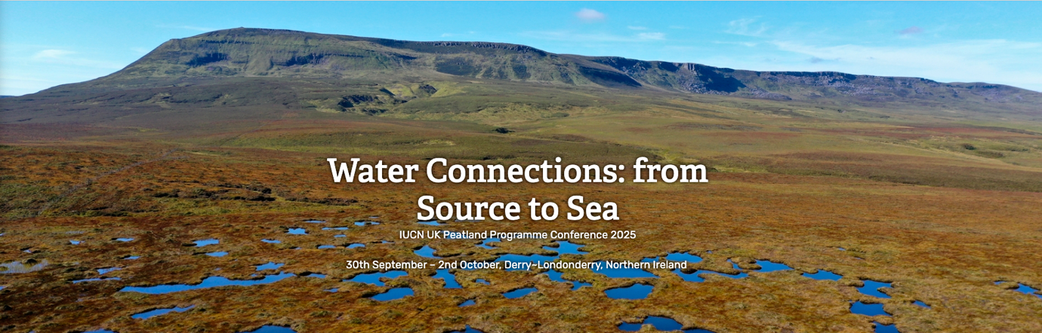

IUCN Peatlands Conference “Water Connections from Source to Sea

Programme

Tuesday 30th September: Plenary sessions (live streamed)

9am – 11am Delegate registration
11am – 12pm Conference welcome and introduction
11am Poetry reading: Angeline King
11.10am IUCN UK Peatland Programme welcome: Jane Akerman, Programme Manager, IUCN UK Peatland Programme
11.25am Welcome address: Julie Thompson, Head of Environment, Marine and Fisheries Group, DAERA
11.40am Northern Ireland’s Peatland Strategy and current initiatives: Mark Preston, Head of Peatland Policy Team, DAERA
12pm – 1pm Lunch
1pm – 2.30pm Peatlands Without Borders: Why Global Action Matters
The UK peatland community is part of a growing number of nations calling for greater understanding, protection and restoration of peatland ecosystems. This session will showcase the IUCN UK Peatland Programme’s role on the international stage, including the development of a Red List for peatland ecosystems and the forthcoming IUCN World Conservation Congress, where we are calling for the adoption of a motion to develop a unified global definition of peat and peatlands. Hear from our partners at the UN Environment Programme-led Global Peatlands Initiative about the outcomes from Ramsar COP15, and join our Virtual Peatlands Pavilion world tour to explore peatlands around the globe.
Speakers
Emma Hinchliffe, Director, IUCN UK Peatland Programme
Richard Lindsay, Peatland Consultant, Richard Lindsay Environment Arts and Letters
Juan Carlos Vasquez, Head of the Biodiversity, People, and Landscape Unit, United Nations Environment Programme
Marko Kohv, Research Fellow, University of Tartu
Māra Pakalne, LIFE PeatCarbon Project Manager, University of Latvia

3pm – 4.30pm Water Connections: Bridging Science, Policy and Practice for a Resilient Future
This plenary session will spotlight the critical role of peatlands in the UK water environment, bringing together leading scientists with water industry and statutory representatives to explore how evidence-based research can inform and transform policy. Through rapid-fire lightning talks, experts will present headline findings - such as how well-managed peatlands can reduce flood peaks and improve water quality - followed by a chaired panel discussion delving into the policy implications. The session aims to drive forward conversations around water security, peatland conservation, and the commitments needed from all four UK nations. It will also explore opportunities for innovation, highlight knowledge gaps, and consider how current policy frameworks support or hinder integrated water and peatland outcomes.
Speakers
David Smith, Natural Resources Manager, South West Water
Philip Jordan, Professor of Catchment Science, University of Ulster
Raymond Flynn, Reader in the School of Natural and Built Environment, Queen’s University Belfast
Florence Renou-Wilson, Senior Lecturer and Principal Investigator, University College Dublin
Additional panel members
Jake White, Team Leader, National Peatland Action Programme, Natural Resources Wales
Katharine Birdsall, Senior Peatland Advisor, Environment Agency
5.30pm – 6.30pm Peatland Bingo
Join our informal networking session to get to know fellow delegates and win some peatland-themed prizes.
6.30pm – 9.30pm Poster and exhibition session

